| Name | Manoj Mani |
| --- | --- |
| Date | 03/01/2024 |
| Email Id | jonam1012@gmail.com |
| Type | Daily Assignment |
| Topic | Creating Storage account |

storage account in azure:

* A storage account is a fundamental resource used to store and manage data.
* Azure Storage provides scalable, secure, and highly available storage solutions for a variety of purposes, such as storing application data, backups, virtual machine disks, and more.

Azure Data Lake Storage:

* It is a scalable and secure data lake solution provided by Microsoft Azure.
* It allows to store and analysis of large amounts of data in its native format with high performance and reliability.

Creating a storage account

In the azure portal search for **storage accounts(classic)** and after selecting that the page is shown below,click create to create a azure storage

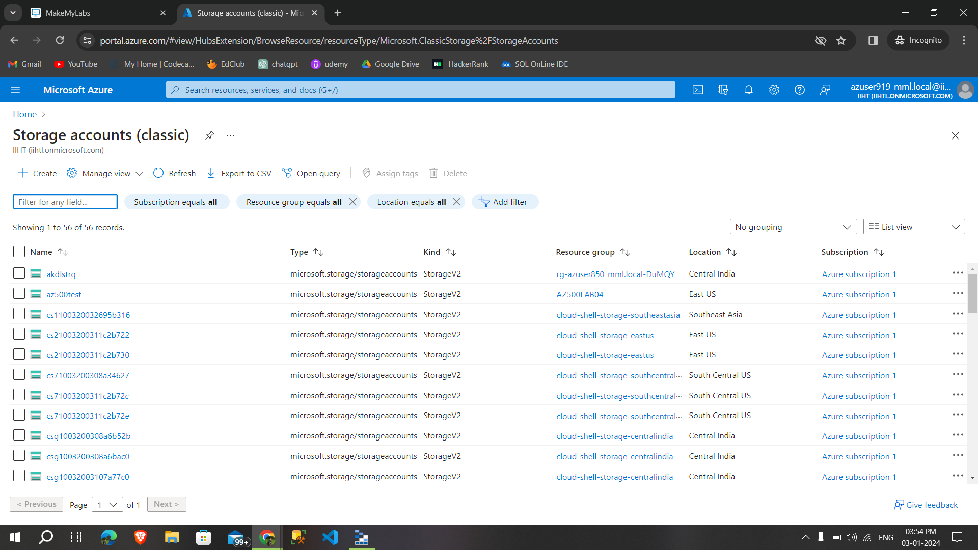

After that, enable **the hierarchical namespace to enable the Azure Data Lake Storage Gen2**

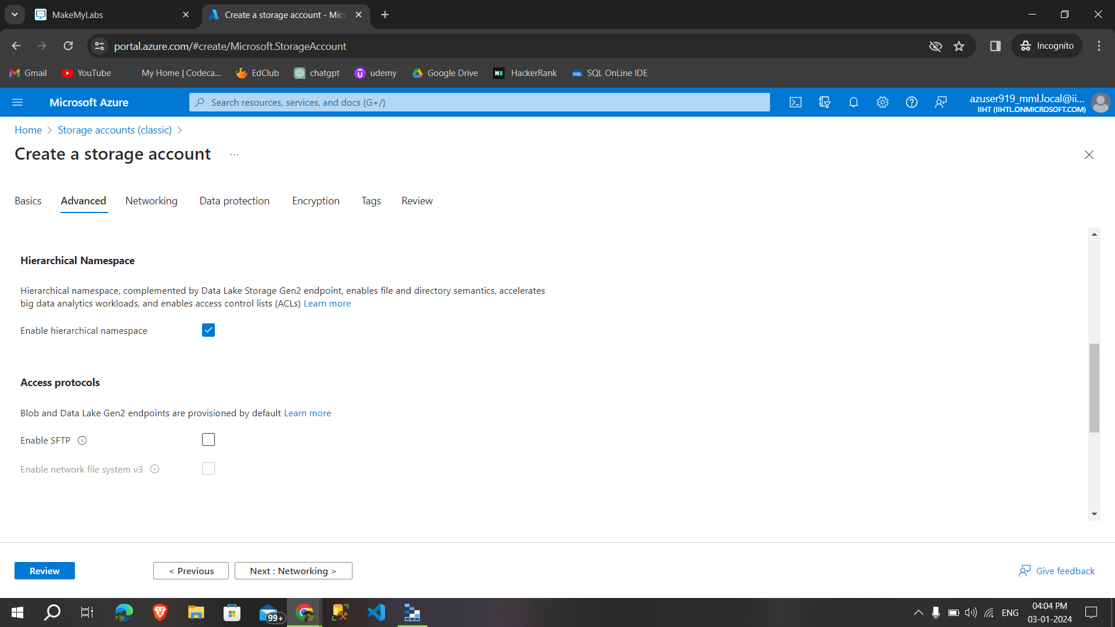

After successfully configured the **storage account click create to create** Azure Data Lake Storage Gen2 storage account

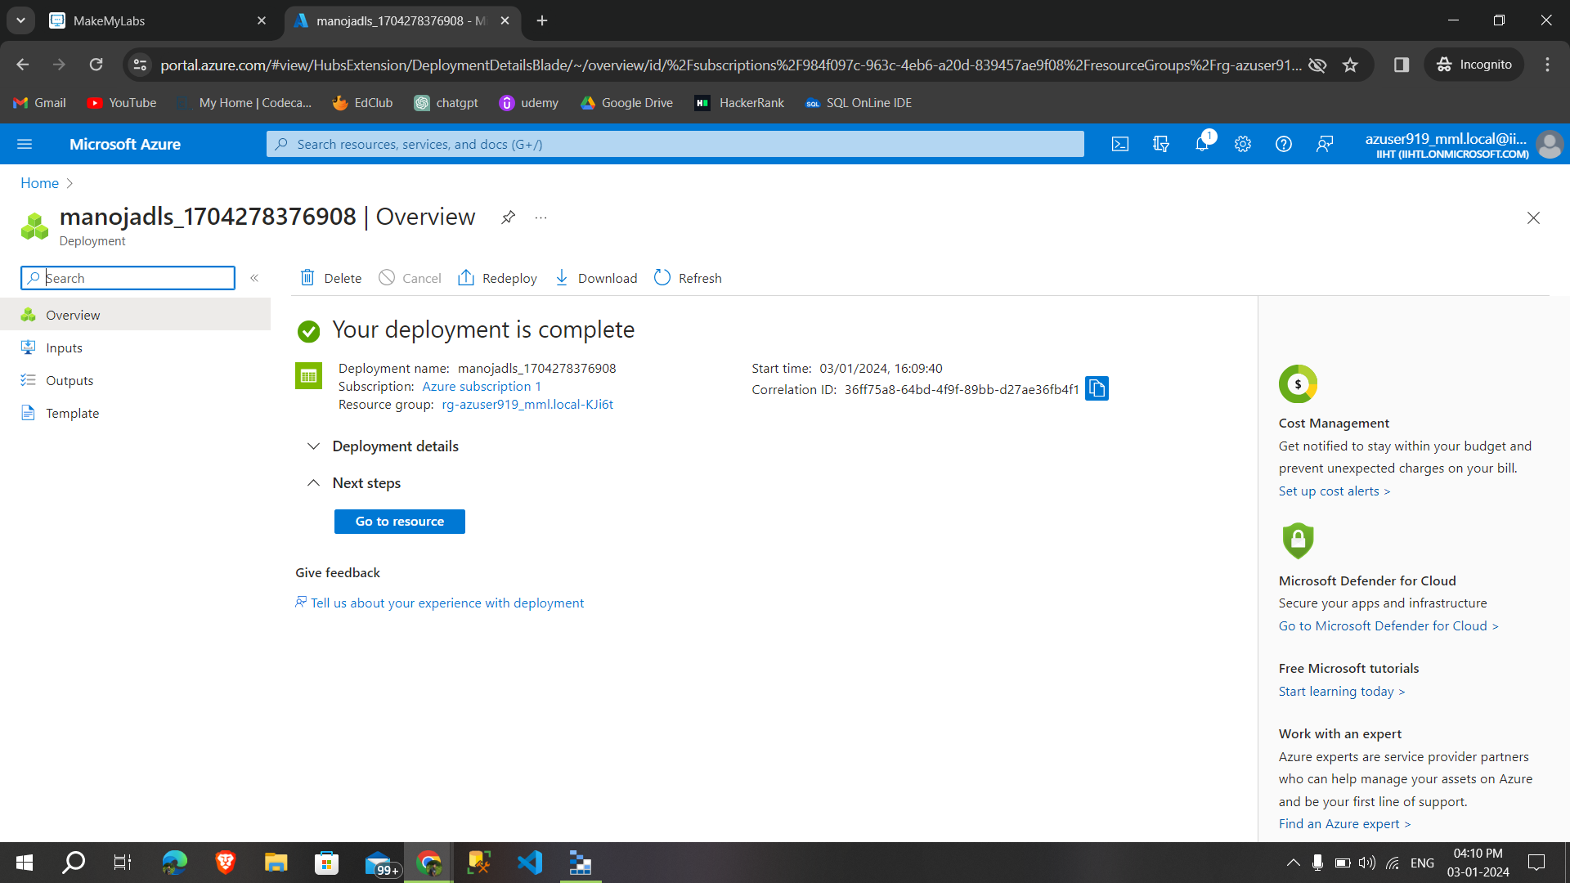

This the overview page of **Azure Data Lake Storage Gen2 storage account** i created,We can see in the properties that **Data lake storage enabled or not**

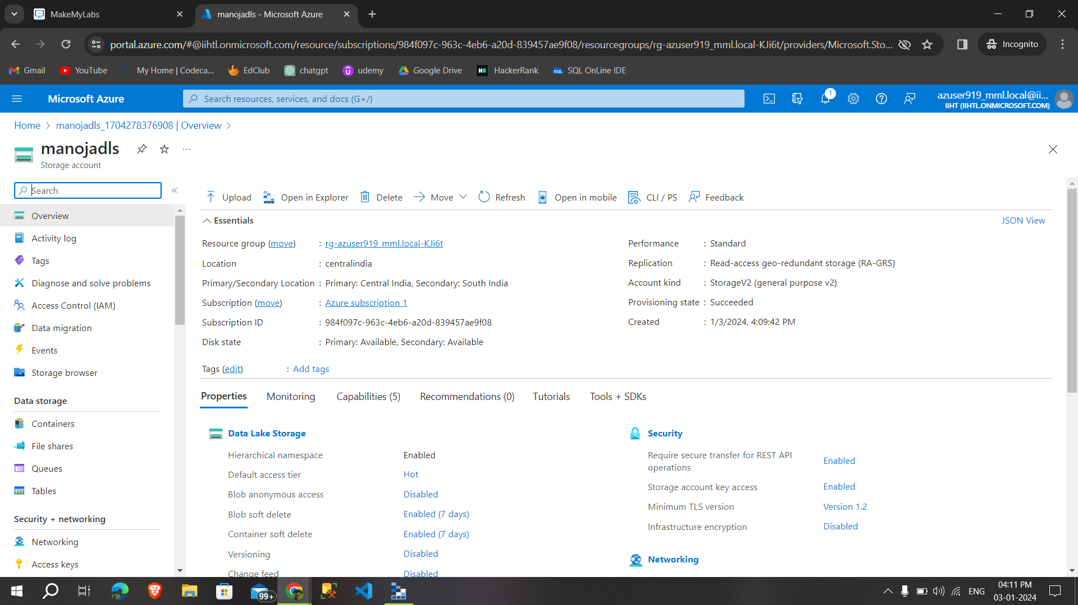

Click on **containers to upload the files** (containers are act like a folder)

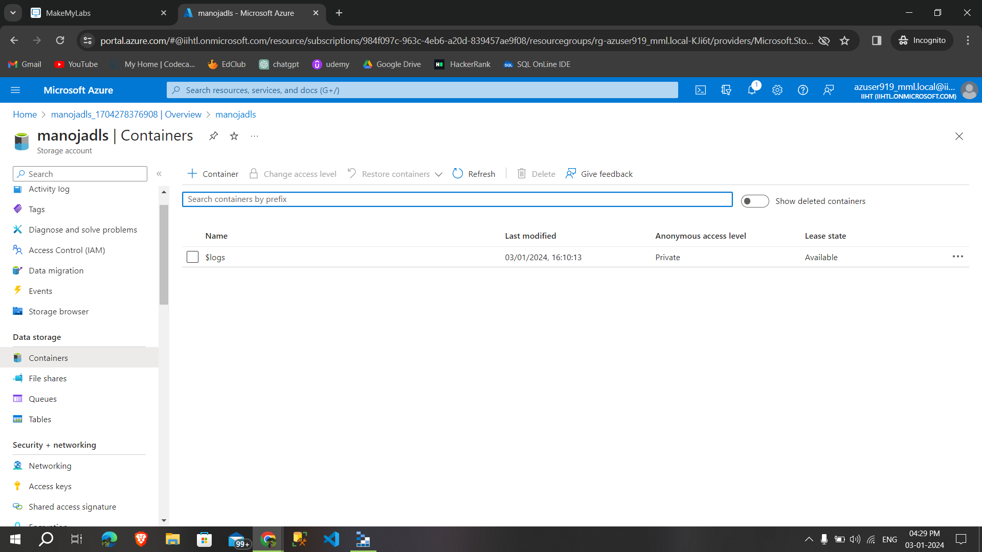

I created a new container called **firstcontainer,**

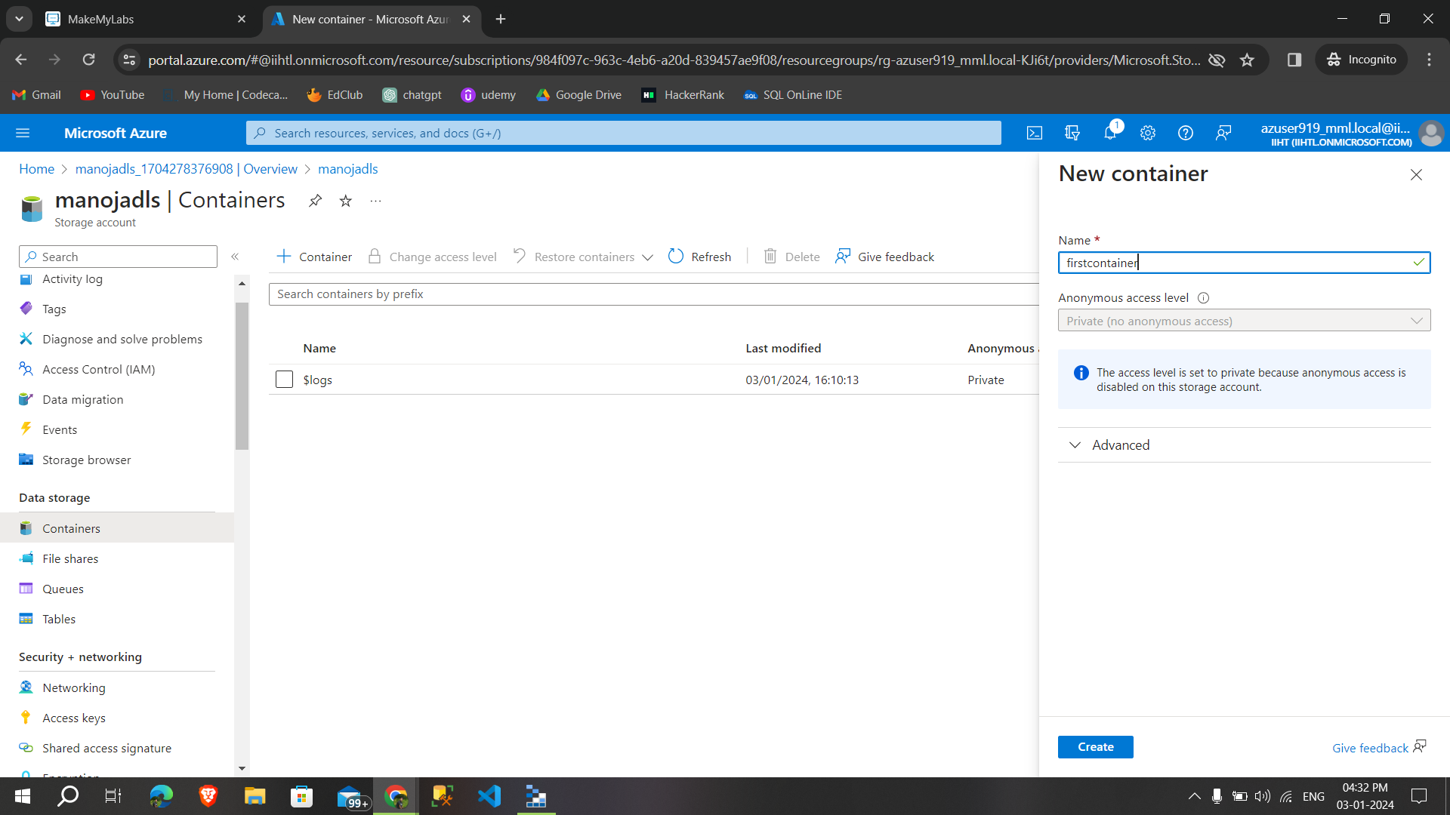

Then I uploaded some csv file in that container,after clicking upload the file will be **uploaded to that container**

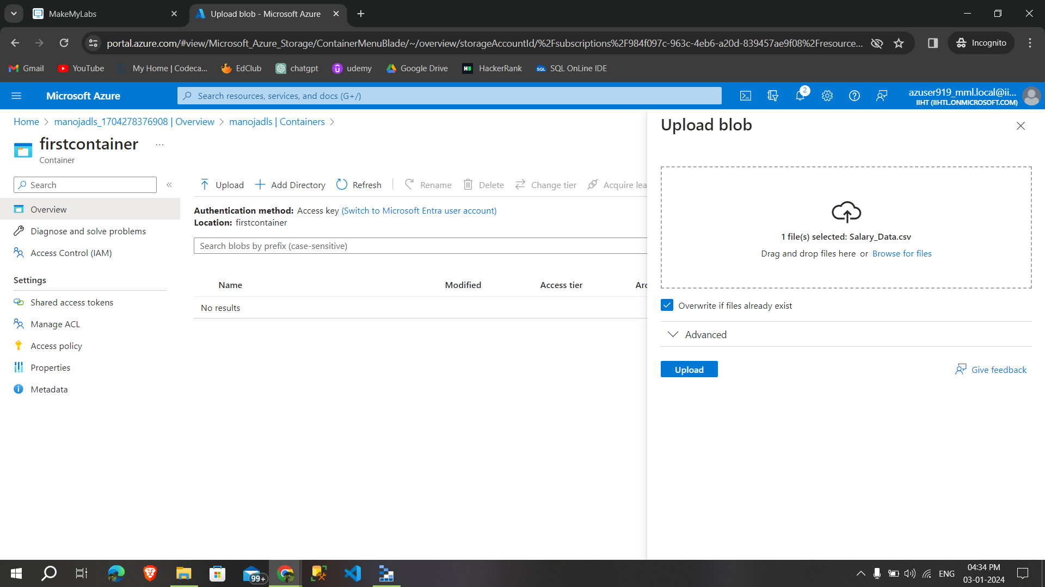

After uploading the file its **shown inside the container,**

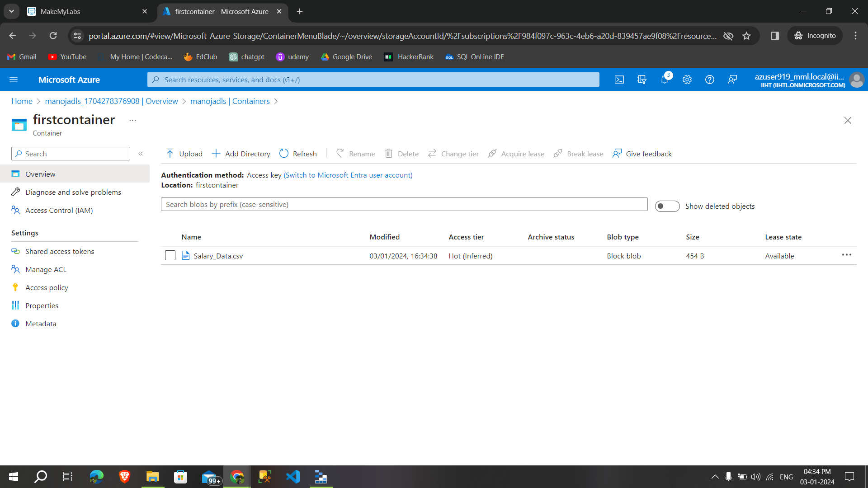

Then we can able to **see more options by clicking the file,**

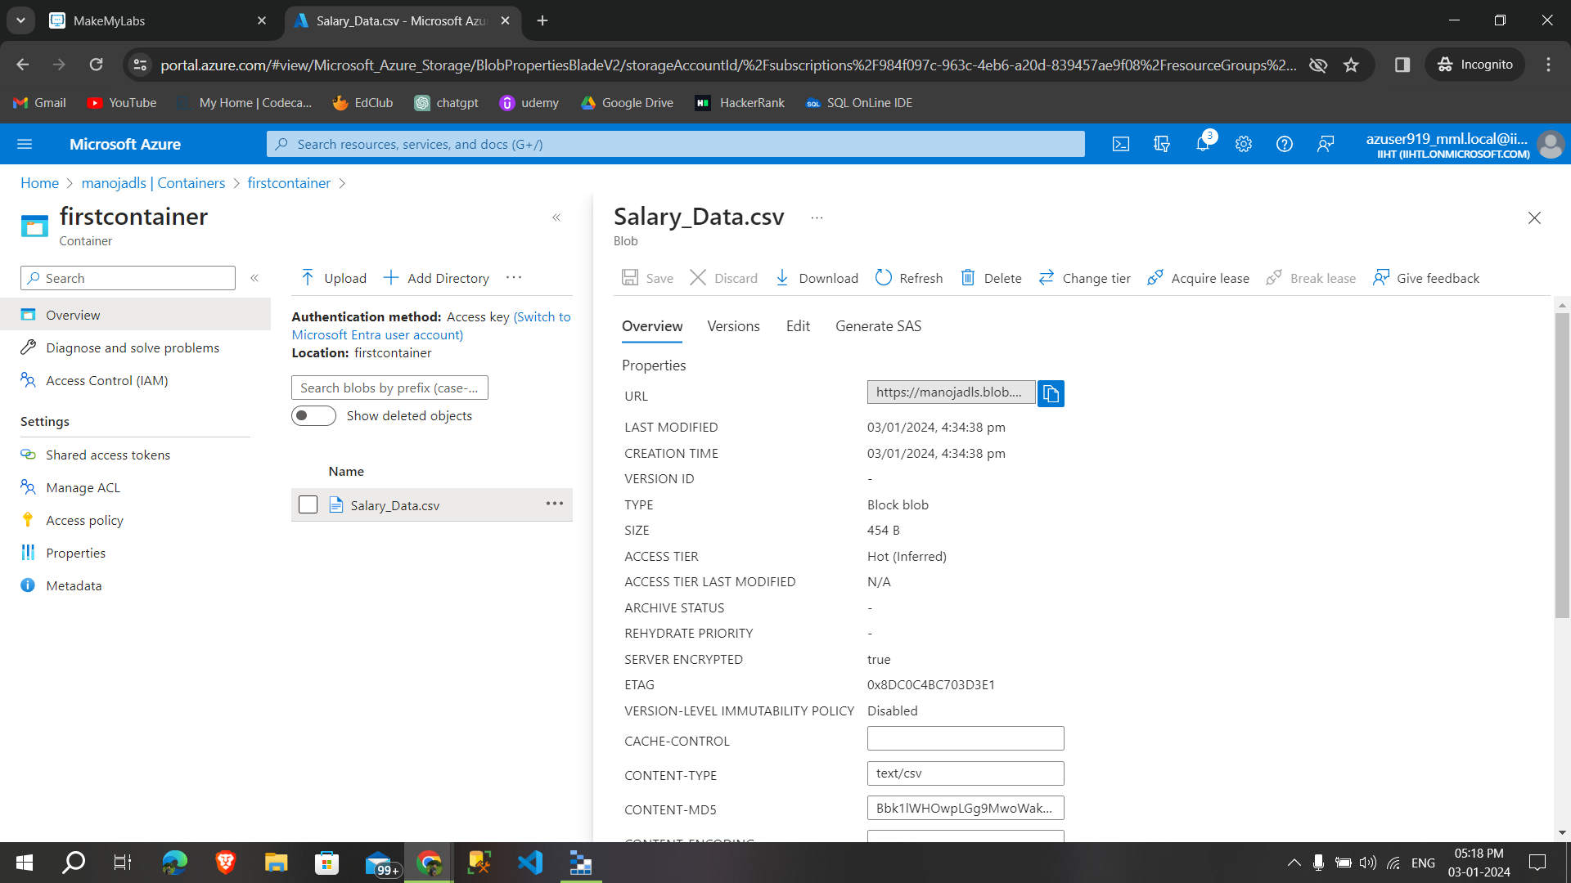

After that i installed the **microsft azure storage explorer** and sign in with azure account,

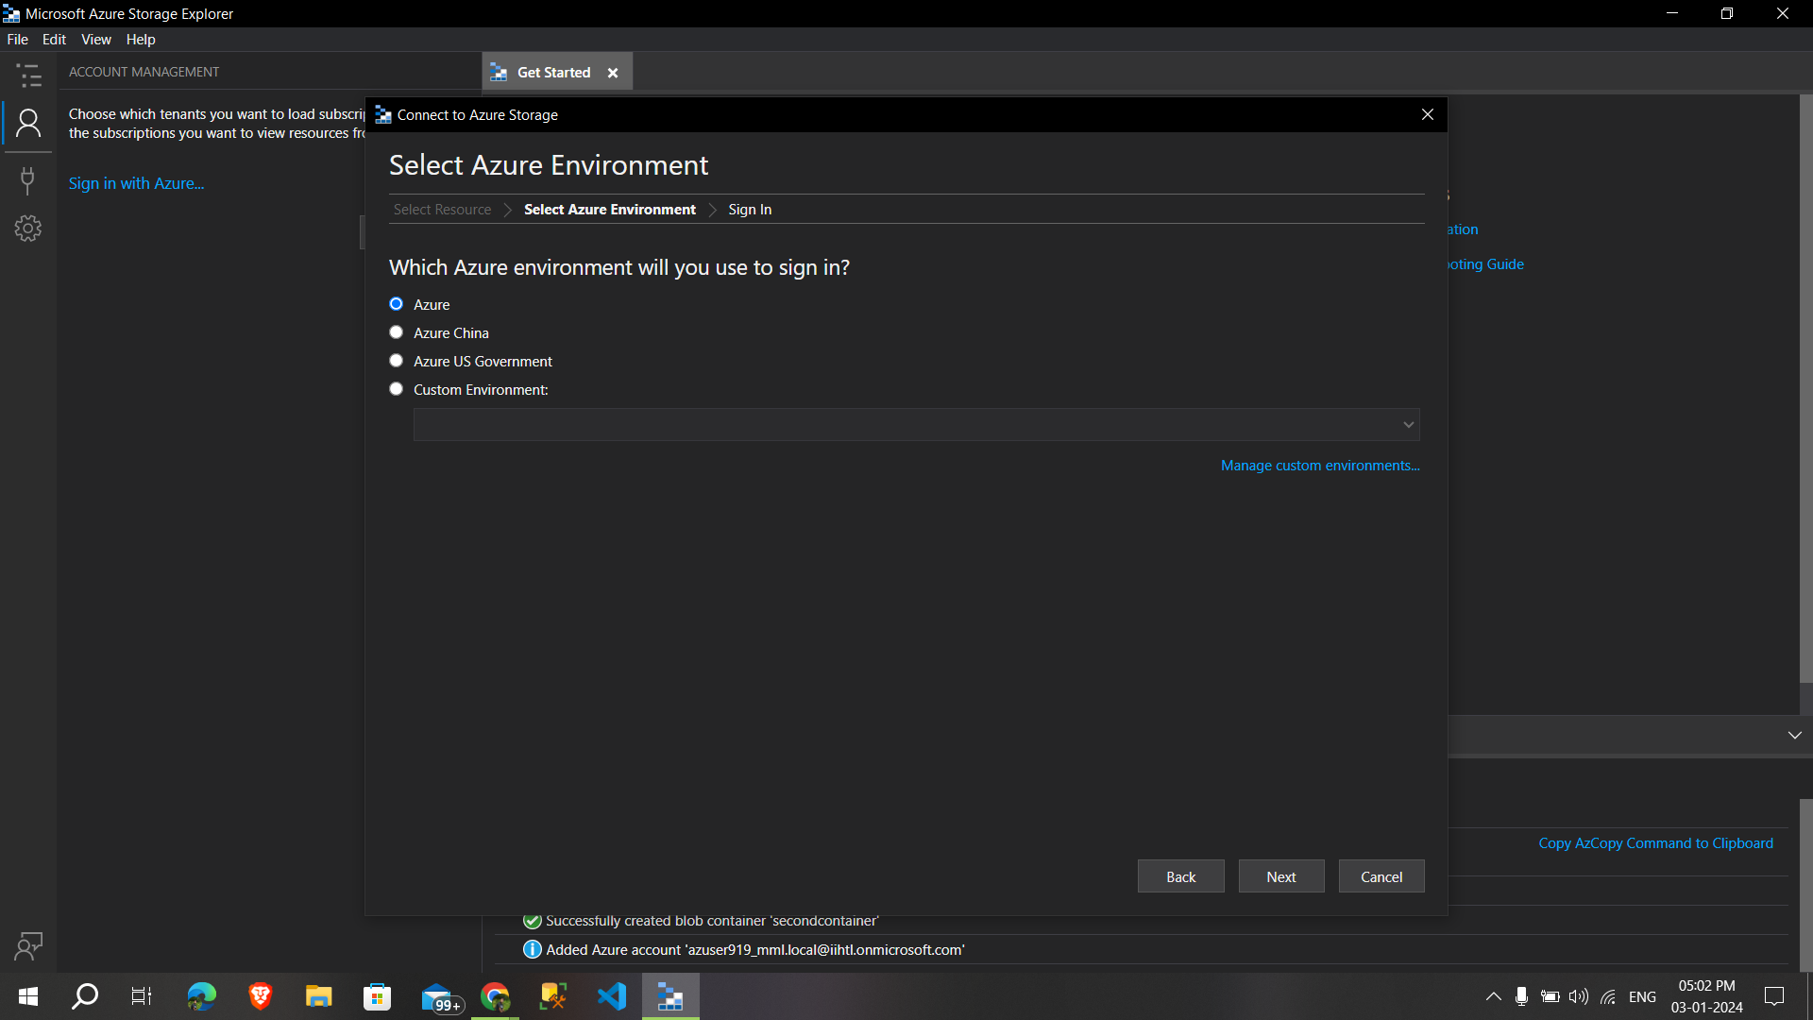

I successfully **signed in and by clicking open explorer** we can able to see our storage accounts

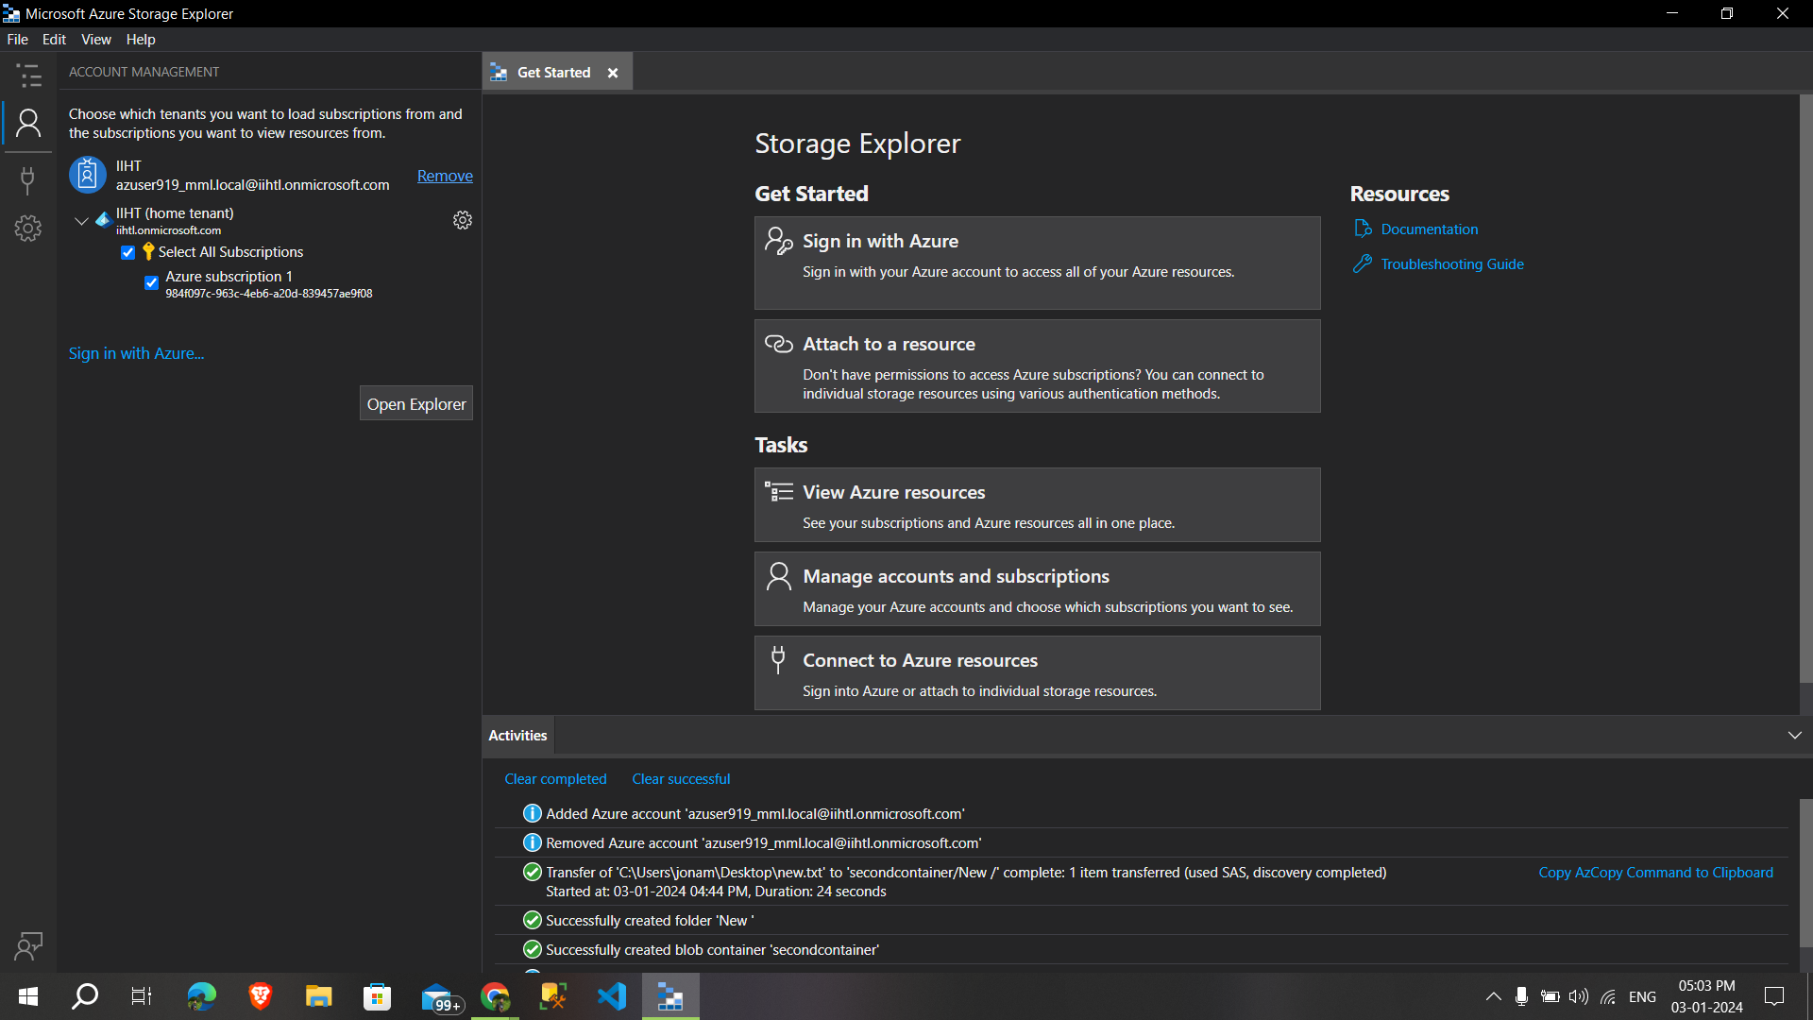

After opening the explorer we can able to **see the storage accounts and the disk,**

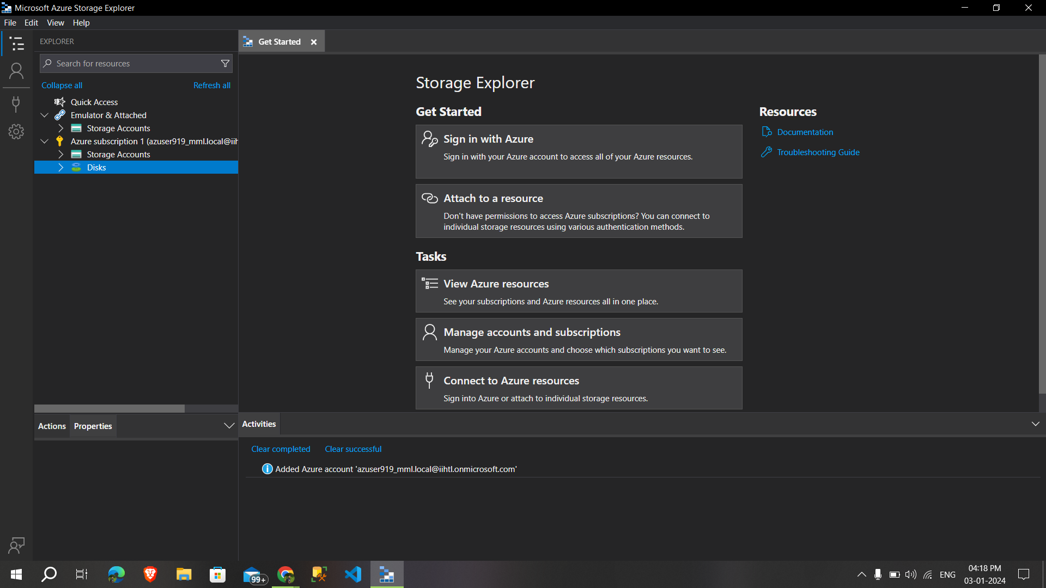

Then i selected the storage account that i have created in the azure portal**(manojadls)**

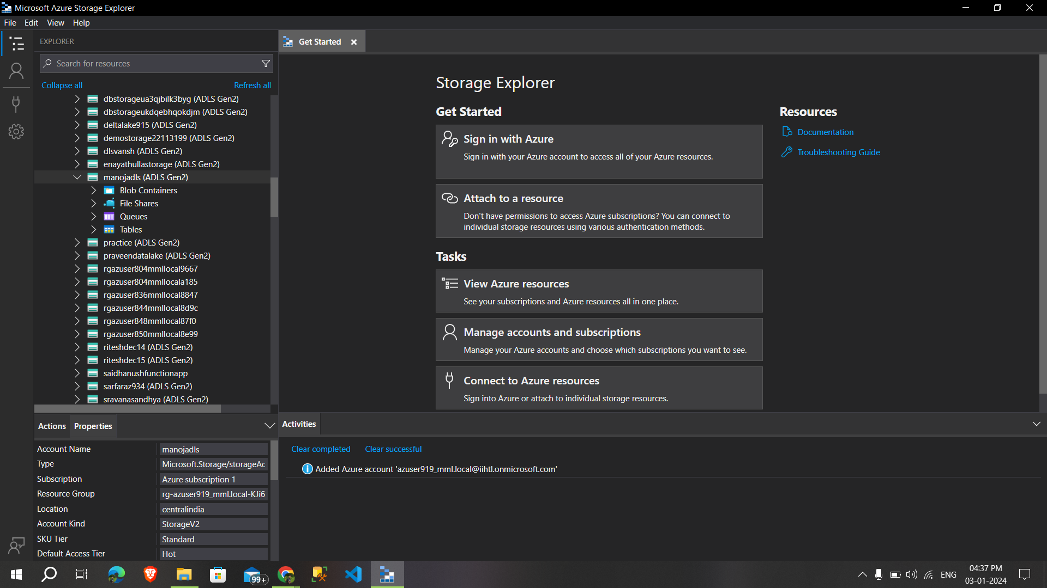

Under that i can able to see the container **i created on the azure portal and now by right clicking the blob container i created a new container**

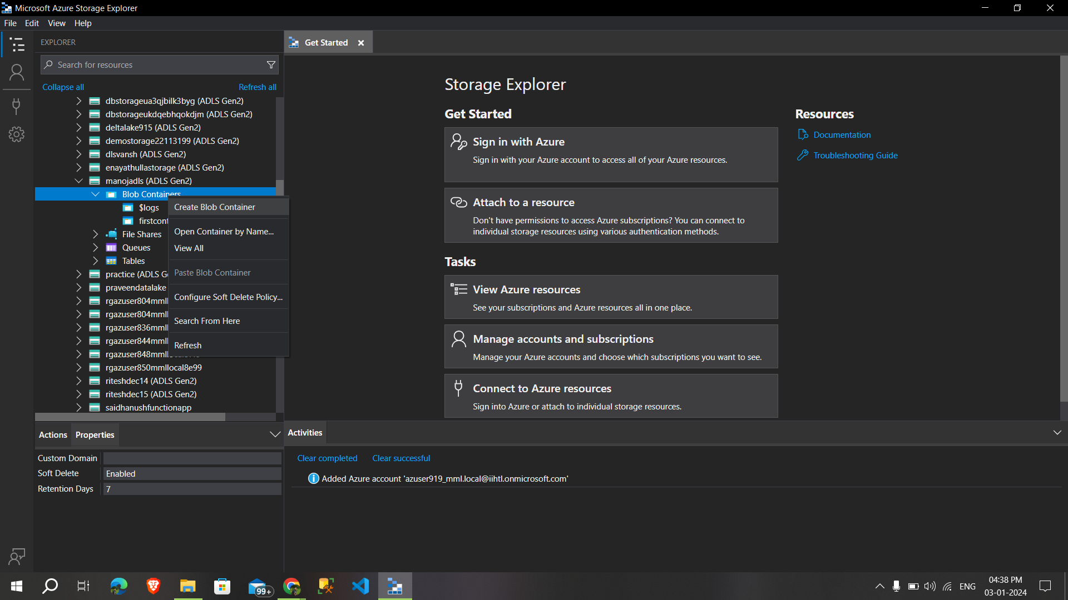

Successfully created a another container called **Secondcontainer** and by selecting the new folder,I just created a new **folder called new,**

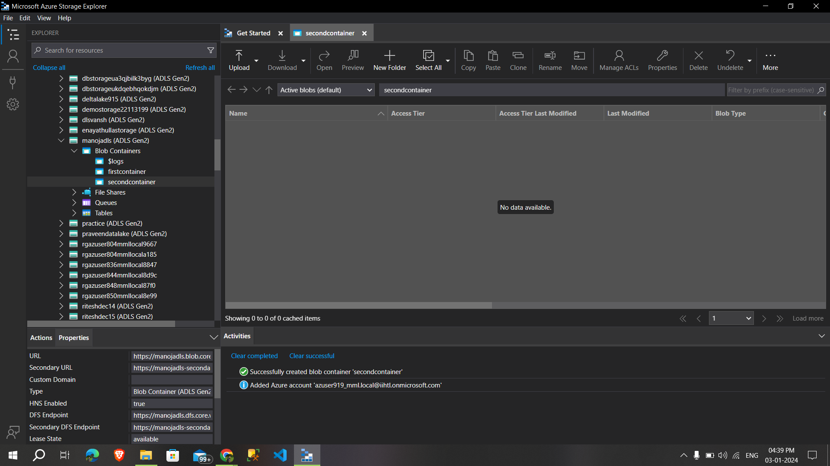

Under the new folder that i’ve created ,adding **one text file by selecting the upload option,**

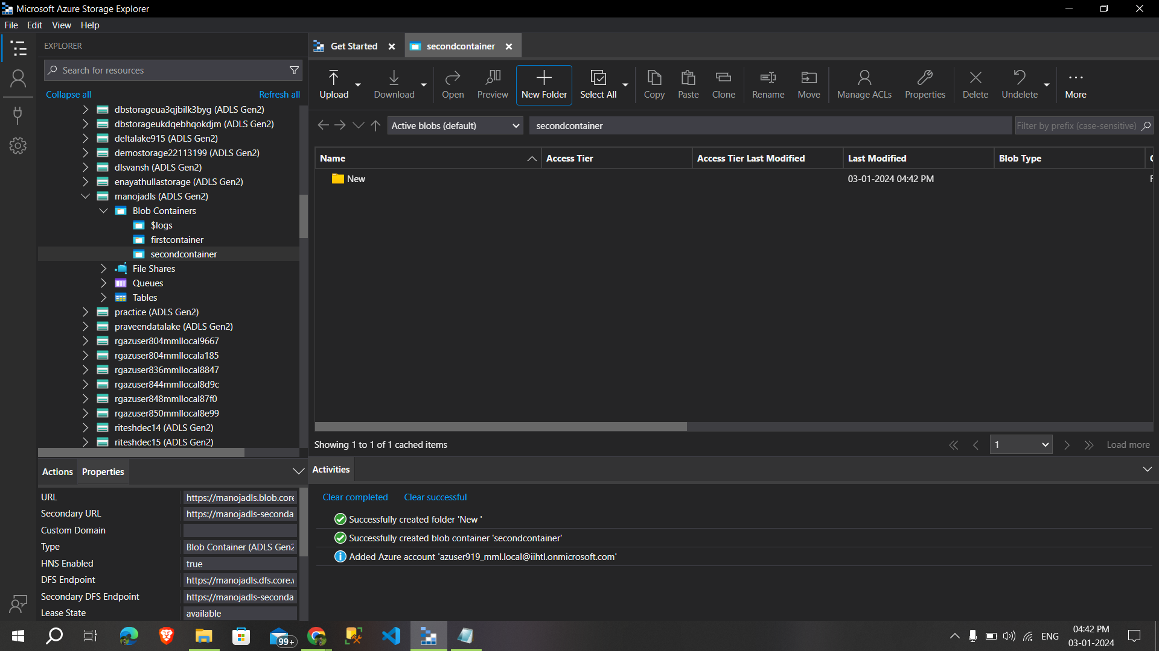

I Successfully uploaded a **text file from the local into azure storage account,**

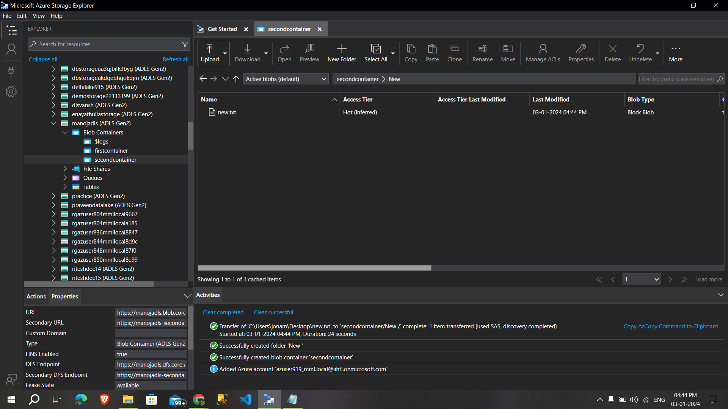

Then i removed my azure account from the azure storage explorer,

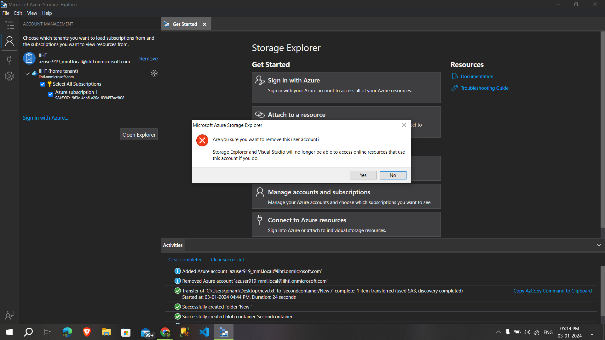

Then i deleted the all containers that i’ve created and delete the storage account

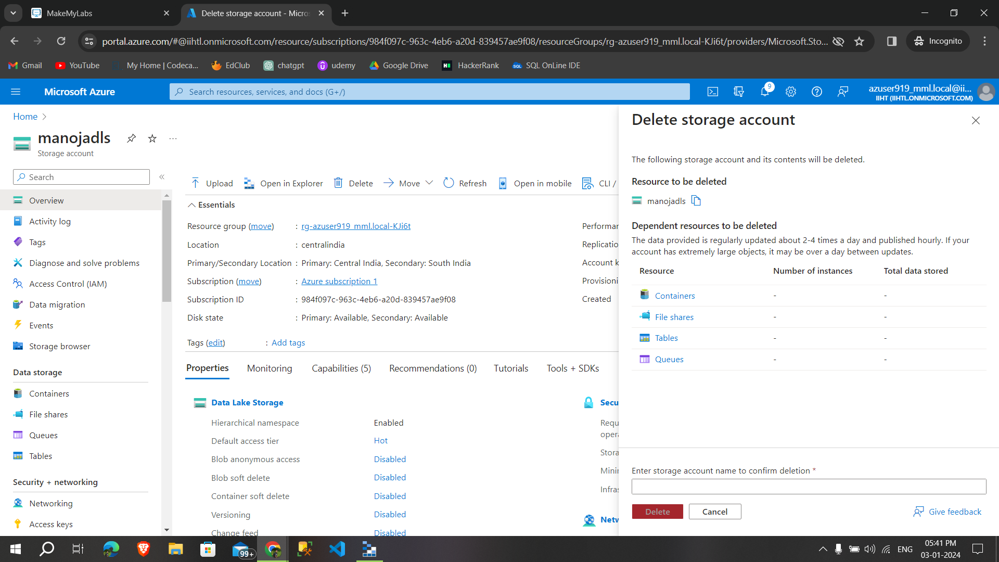

After typing the storage account name in the box,Then Successfully deleted the storage account